May 2012 Volume 55 AOPA

Fly-Outs: French Valley Airport

Something for everybody in this pleasant valley
By Geri Silveira

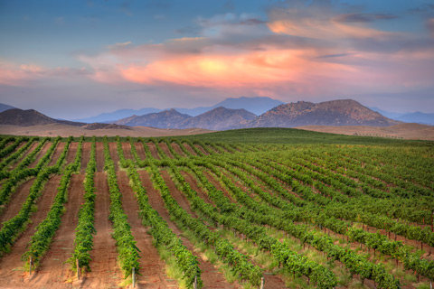
French Valley is nowhere near France, but it is near Perris (pronounced “Paris”), about 20 miles north. Its namesake airport, French Valley (F70), is in the heart of Southern California, just 55 miles north of San Diego. It’s bordered by the cities of Murrieta, famous for its hot springs; Winchester, known for its cheese company; and Temecula, whose history includes a stagecoach robbery, Indian skirmishes, and a short-lived railroad boom in the late 1880s.

WANT TO KNOW MORE?
- Aircraft from ultralights to jets are welcome
- Heads up: Avoid the skydiving area near Lake Elsinore
- For pilot supplies or a snack: French Valley Flight Center
- Transportation: Rental cars (call ahead)
- Airport information: rcfva.com; 951-600-7207
- Visitor information:temeculacvb.com
French Valley Airport has a 6,000-foot runway that accommodates aircraft from jets to Jennies, and there’s plentiful parking and fuel. For pilots and passengers who need to fill up, French Valley Café is in the terminal building, and for helicopter buffs, the Wings and Rotors Air Museum is also on the field. For longer stays, there’s something for everybody in this pleasant valley. Temecula is a popular place for wine tasting at the area’s more than 30 wineries. Other activities include hot air ballooning, hiking, horseback riding, golf, and gaming at the nearby Pechanga Resort & Casino.
Shoppers won’t want to miss downtown Old Town Temecula with its array of boutiques, antique stores, art galleries, and restaurants. Ambling down the boardwalk, visitors get a taste of “the West that was,” viewing Old Town’s western-style storefronts.
A nontowered airport, French Valley can get busy on weekends and the mix of aircraft can be interesting, so “see and avoid” is a good practice for pilots and passengers. Flying to and from French Valley, sightseeing opportunities abound, including lakes, mountains, and Mount Palomar Observatory.
